OS Lab #5
Question 1

Producer

/*
Write a producer and consumer program in C using the FIFO queue.
The producer should write a set of 4 integers into the FIFO queue
and the consumer should display the 4 integers.
*/

#include<stdio.h>
#include<stdlib.h>
#include<unistd.h>
#include<sys/types.h>
#include<limits.h>
#include<fcntl.h>
#include<sys/msg.h>
#include<sys/stat.h>
#include<string.h>

#define FIFO_NAME "my_fifo"
#define BUFFER_SIZE 1000

int main(int argc, char *argv[])
{
int pipe_fd;
int res;
int open_mode=O_WRONLY;
int n=0;
char buffer[BUFFER_SIZE+1];

if(access(FIFO_NAME,F_OK)==-1)
{
res=mkfifo(FIFO_NAME,0777);
if(res!=0)
{
fprintf(stderr, "Could not create file%s\n",FIFO_NAME );
exit(EXIT_FAILURE);
}
}

printf("Process %d opening FIFO O_WRONLY\n",getpid());
pipe_fd=open(FIFO_NAME,open_mode);
printf("Process %d result %d\n",getpid(),pipe_fd);

if (pipe_fd!=-1)
{
printf("Enter 4 numbers\n");

while(n<4)
{
scanf("%s",buffer);
res=write(pipe_fd,buffer,BUFFER_SIZE);

if(res==-1)
{
fprintf(stderr, "Write Error on Pipe\n");
exit(EXIT_FAILURE);
}
n++;
}
(void)close(pipe_fd);
}
else
exit(EXIT_FAILURE);

printf("Process %d Finished\n",getpid() );
exit(EXIT_SUCCESS);

}

Consumer

/*
Write a producer and consumer program in C using the FIFO queue.
The producer should write a set of 4 integers into the FIFO queue
and the consumer should display the 4 integers.
*/

#include<stdio.h>
#include<stdlib.h>
#include<unistd.h>
#include<sys/types.h>
#include<limits.h>
#include<fcntl.h>
#include<sys/msg.h>
#include<sys/stat.h>
#include<string.h>

#define FIFO_NAME "my_fifo"
#define BUFFER_SIZE 1000

int main(int argc, char *argv[])
{
int pipe_fd;
int res;
int open_mode=O_RDONLY;
int n=0;
char buffer[BUFFER_SIZE+1];
memset(buffer,'\0',sizeof(buffer));

printf("Process %d opening FIFO O_RDONLY\n",getpid());
pipe_fd=open(FIFO_NAME,open_mode);
printf("Process %d result %d\n",getpid(),pipe_fd);

if (pipe_fd!=-1)
{
do
{
res=read(pipe_fd,buffer,BUFFER_SIZE);
printf("%s\n",buffer );
n++;
}while(n<4);

(void)close(pipe_fd);
}

else
exit(EXIT_FAILURE);

printf("Process %d Finished, %d bytes read\n",getpid(),n );
exit(EXIT_SUCCESS);
}

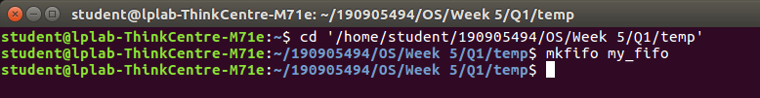
Creating FIFO Pipe

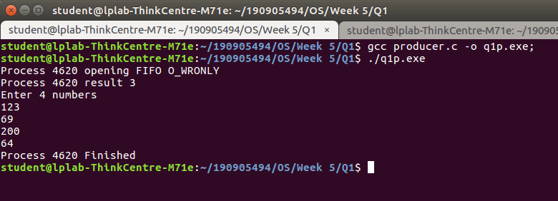
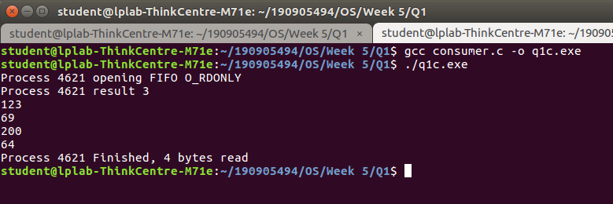

Question 2

// Demonstrate creation, writing to, and reading from a pipe.

#include<stdio.h>
#include<stdlib.h>
#include<unistd.h>
#include<sys/types.h>
#include<sys/ipc.h>
#include<sys/msg.h>
#include<string.h>

int main(int argc, char *argv[])
{
int n, i=0;
int fd[2];
char buf[1025];
char *data = "Hello How Are You";

// creating
pipe(fd);

// Writing
while(i<strlen(data)){
write(fd[1],data,strlen(data));
i++;
}

// reading
i=0;
while(i<strlen(data)){
if(n=read(fd[0],buf,1024)>=0)
{
buf[n]='\0';
printf("Read %d bytes from pipe\"%s\"\n",n,buf);
} else
perror("Read");
exit(0);
i++;
}
}

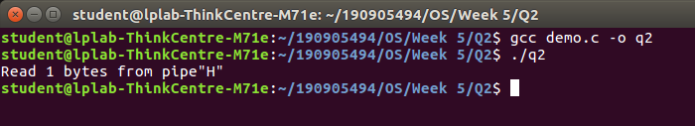

Question 3

Parent

/*
Write a C program to implement one side of FIFO.
*/

#include<stdio.h>
#include<stdlib.h>
#include<unistd.h>
#include<sys/types.h>
#include<limits.h>
#include<fcntl.h>
#include<sys/msg.h>
#include<sys/stat.h>
#include<string.h>

#define FIFO_NAME "my_fifo"
#define BUFFER_SIZE 10000

int main(int argc, char *argv[])
{
int pipe_fd;
int res;
int open_mode1=O_WRONLY;
int open_mode2=O_RDONLY;
int n=0;
char buffer[BUFFER_SIZE+1];

if(access(FIFO_NAME,F_OK)==-1)
{
res=mkfifo(FIFO_NAME,0777);

if(res!=0)
{
fprintf(stderr, "Could not create file%s\n",FIFO_NAME);
exit(EXIT_FAILURE);
}
}

printf("You can start chatting with User 2 now\n");

while(1)
{
pipe_fd=open(FIFO_NAME,open_mode2);

printf("\nText from User 1: ");
res=read(pipe_fd,buffer,BUFFER_SIZE);
printf("%s\n",buffer );
close(pipe_fd);

printf("Wait for User 1 reply...\n");
pipe_fd=open(FIFO_NAME,open_mode1);

printf("\nEnter Text to send User 1: ");
fgets(buffer,BUFFER_SIZE,stdin);
res=write(pipe_fd,buffer,BUFFER_SIZE);

close(pipe_fd);

}

(void)close(pipe_fd);

printf("Process %d Finished\n",getpid());
exit(EXIT_SUCCESS);
}

Child

/*
Write a C program to implement one side of FIFO.
*/

#include<stdio.h>
#include<stdlib.h>
#include<unistd.h>
#include<sys/types.h>
#include<limits.h>
#include<fcntl.h>
#include<sys/msg.h>
#include<sys/stat.h>
#include<string.h>

#define FIFO_NAME "my_fifo"
#define BUFFER_SIZE 10000

int main(int argc, char *argv[])
{
int pipe_fd;
int res;
int open_mode1=O_WRONLY;
int open_mode2=O_RDONLY;
int n=0;
char buffer[BUFFER_SIZE+1];

if(access(FIFO_NAME,F_OK)==-1)
{
res=mkfifo(FIFO_NAME,0777);

if(res!=0)
{
fprintf(stderr, "Could not create file%s\n",FIFO_NAME);
exit(EXIT_FAILURE);
}
}

printf("You can start chatting with User 2 now\n");

while(1)
{
pipe_fd=open(FIFO_NAME,open_mode1);

printf("\nEnter Text to send User 2: ");
fgets(buffer,BUFFER_SIZE,stdin);
res=write(pipe_fd,buffer,BUFFER_SIZE);

close(pipe_fd);

printf("Wait for User 2 reply...\n");
pipe_fd=open(FIFO_NAME,open_mode2);

printf("\nText from User 2: ");
res=read(pipe_fd,buffer,BUFFER_SIZE);
printf("%s\n",buffer );
close(pipe_fd);

}

(void) close(pipe_fd);

printf("Process %d Finished\n",getpid());
exit(EXIT_SUCCESS);
}

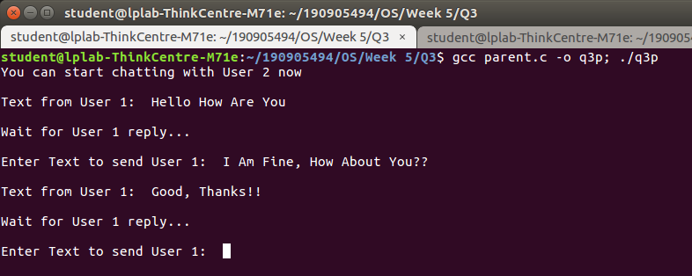
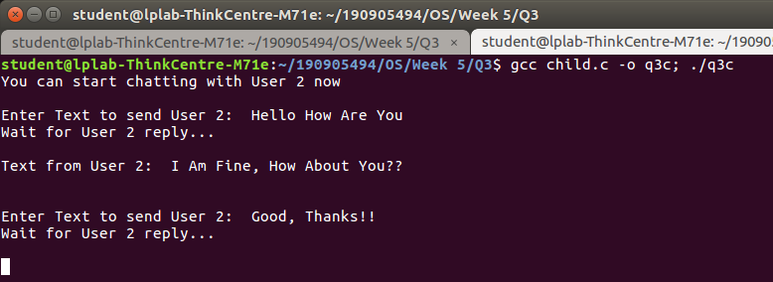

Question 4

/*
Write a C program reading and writing a binary file in C.
*/

#include<stdio.h>
#include<stdlib.h>

int main()
{

FILE* fptr;
int num=0;
fptr=fopen("demo.bin","wb+");

printf("Enter some numbers : \n");

for(int i=0;i<4;i++)
{

scanf("%d",&num);
fwrite(&num,sizeof(int),1,fptr);
}

printf("Writing done!\n");
fclose(fptr);

fptr=fopen("demo.bin","rb");

for(int i=0;i<4;i++)
{

fread(&num,sizeof(int),1,fptr);
printf("%d\n",num);
}

}

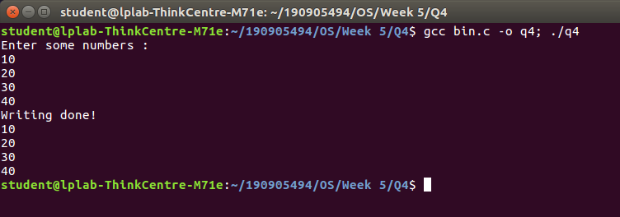

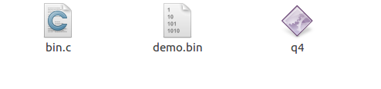

‘demo.bin’ file created to read and write from

